Dear Friends,

We are back home after a long journey from Uganda, where we spent 3 weeks. Thank you for all the prayers. The Lord was faithful and protected us all the time. We weren’t sick even once.
Of course there were many uncomfortable situations in everyday life we weren’t used to, but we were prepared for that. There were also some cultural differences that were a problem to us, but we learned how to manage them. We were very busy with our activities.
God was with us in many difficult and unexpected situations. One of them was a car accident. We were travelling by car with 3 other people and an antelope ran into the road in front of us. We didn’t hit it, but the car fell over on its side. Nobody was seriously injured. It could have been much worse. Praise the Lord for His care.

Lila had many meetings and workshops with Sunday school teachers, parents and teachers-to-be. She shared topics like: a child in God’s eyes, how to be a godly teacher, why we should teach children God’s word and how to evangelize children. These simple and obvious topics for us are necessary, challenging and very useful there. The teachers responded very well to the lectures, people had new ideas how to make a difference in Bible education for children. Thanks to a pastor we met, Lila was able to influence 11 churches. She was encouraged to see interest in those people and how God was active among us. It was a great satisfaction. We also organized a conference for 150 children in one of the villages. Lila always had a dream of teaching little African children the Bible in the shade of a big tree and it literally came true when she shared the Gospel with them using the Wordless Book. That was also a time when we experienced God’s blessing – we weren’t expecting that many children, but there was enough food for every one of them and we were able to handle such a big group with just a few people to help.

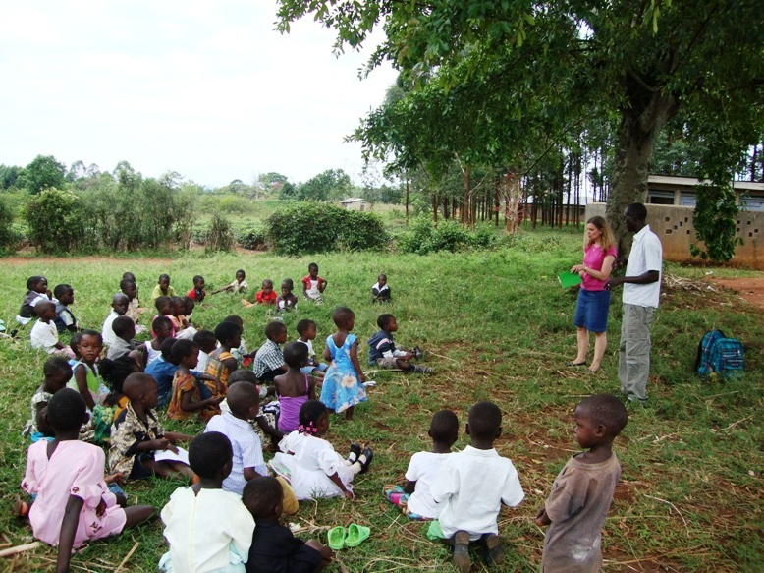
Natalia had lessons and activities for children in schools and orphanages. With her friend Ania they taught Bible, English and Geography lessons in a creative way. The children there aren’t used to those kinds of lessons, their education is focused on simply repeating after the teacher. Hopefully the teachers will use some of our ideas and find their own ways to make school more interesting. They also spent time with orphans, playing games with them and just giving them love and attention they don’t often experience.

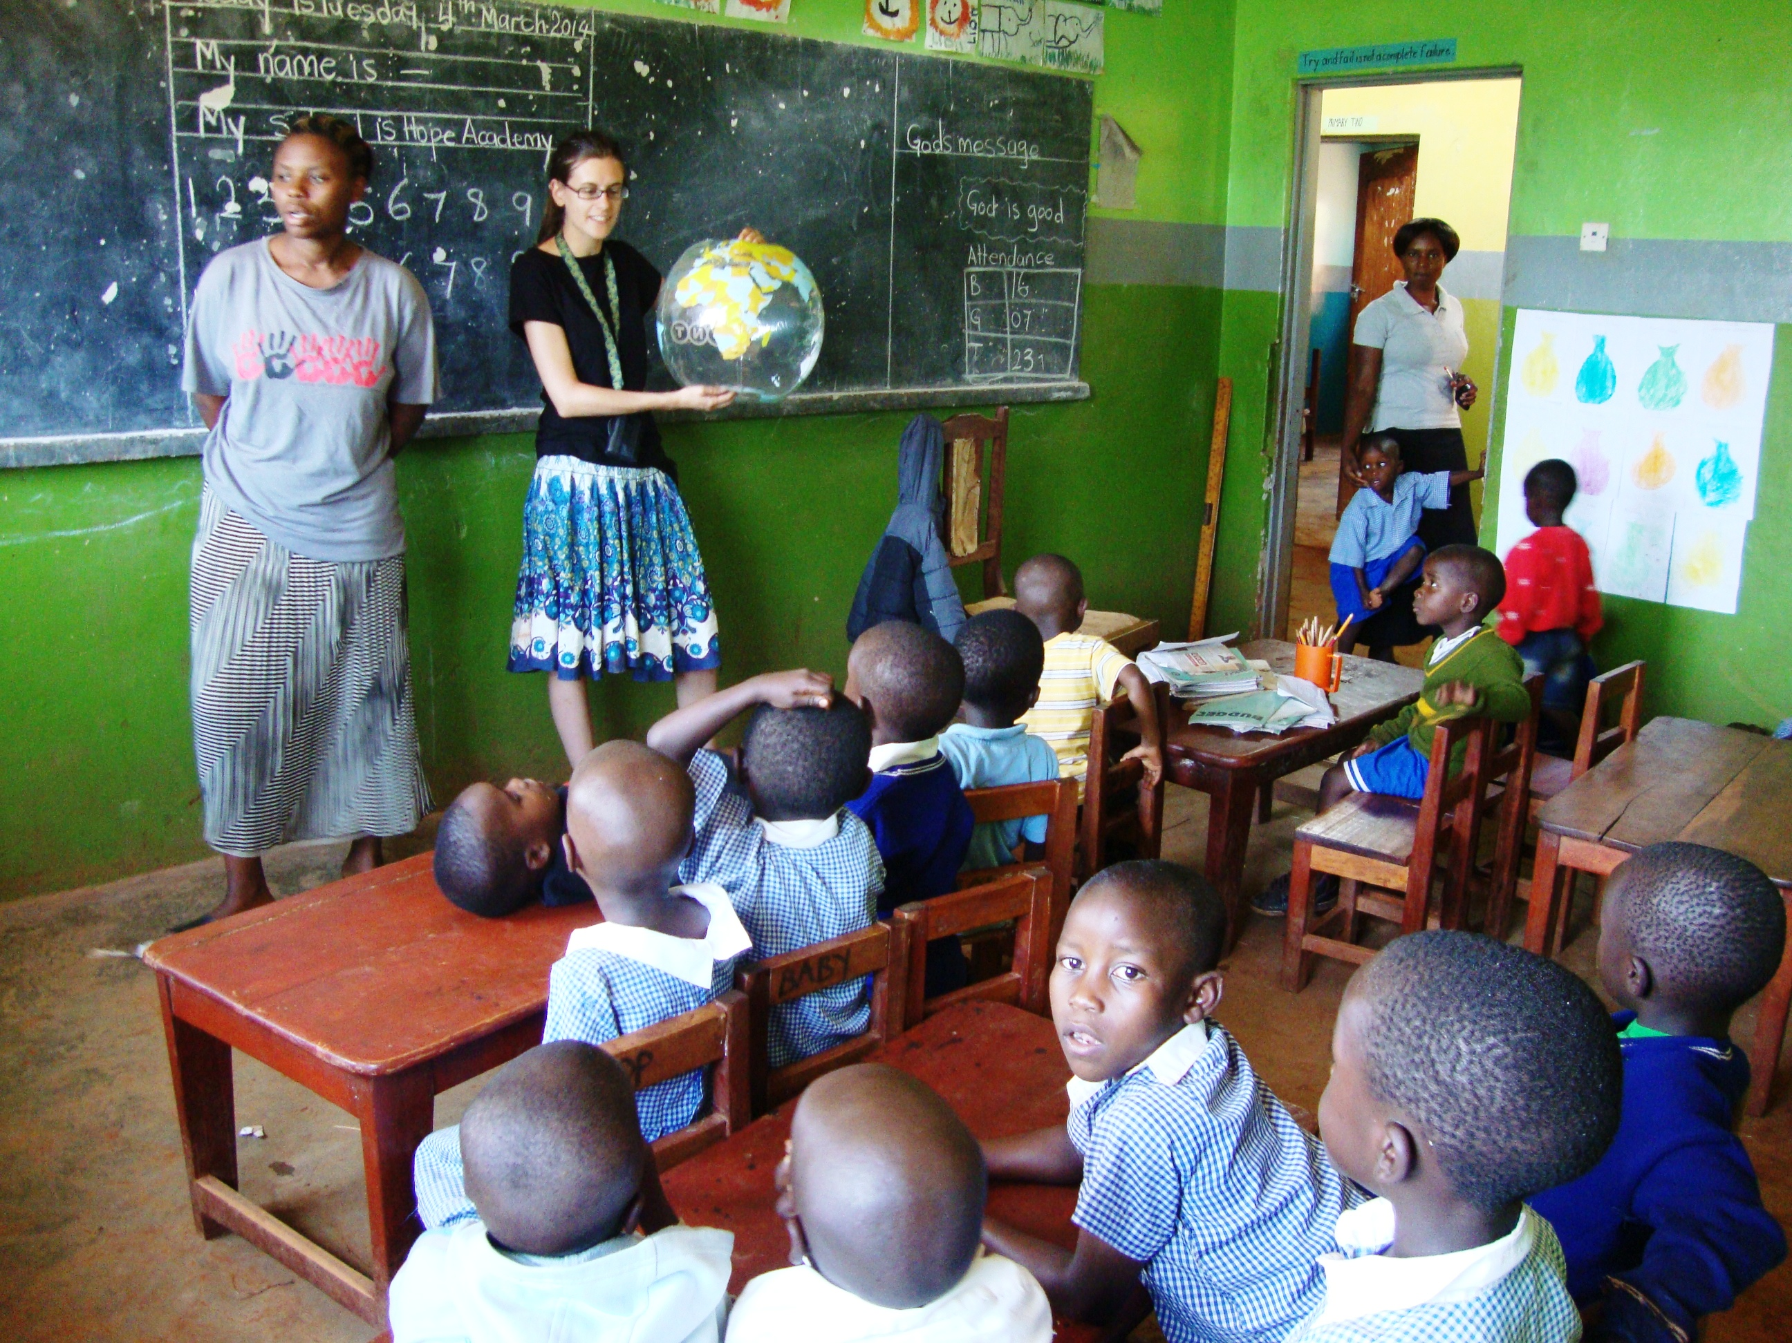

We enjoyed the sunny weather, beautiful nature and tasty fruits. This trip was an interesting and eye-opening experience. All the time we had in mind Psalm 91 and we saw the Lord keeping those promises:
Surely He shall deliver you from the snare of the fowler and from the perilous pestilence. He shall cover you with His feathers, and under His wings you shall take refuge. (Psalm 91,3-4)

We thank all of you who made this possible for us. Thank you for the financial support, words of encouragement and prayer. God bless you.

Lila and Natalia

Lila and Natalia Groth
32-434 Skomielna Biala
Nr. 623
POLAND
nataliagroth@interia.pl

ECMI-USA
P.O. Box 181
West Unity OH
43570-0181

ecmi.usa@ecmi.org
www.ecmi-usa.org

